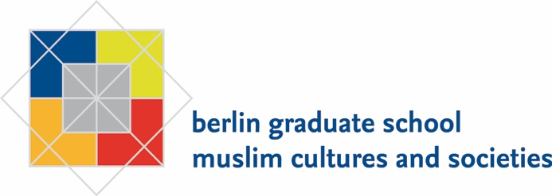

EXPLORING VIOLENCE, SURVEILLANCE, & AUTHORITARIAN CONTROL:
ANTHROPOLOGICAL APPROACHES TO ETHICS, SUBJECTIVITY, & JUSTICE
Workshop held at Berlin Graduate School Muslim Cultures and Societies, Hittorfstr. 18, 14195 Berlin

Date:
November 15, 2021, 1.30-5-30 pm

Workshop Outline:
This half-day in-person workshop brings two researchers, Dr Erol Saglam (BGSMCS, Germany) and Dr Deniz Yonucu (Newcastle University, UK) together with ten doctoral students to explore the reverberations of ethnographic research in contexts that are plagued by suspicion, surveillance, and violence. It directly tackles how such engagements force researchers to rethink the anthropological conventions around ethics as well as theoretical articulations around statecraft, agency, and subjectivity.

Rationale & Objectives
Conducting ethnographic research across and alongside violent encounters, state surveillance, and authoritarian control has always been one of the most challenging aspects of ethnographic research. Violence, both among civilian groups/actors and by state agents, has often been remarked to exert a corrosive effect upon social bonds, affecting the way anthropologists operate within the field. Civil wars waged by competing armed groups, communal conflicts alongside confessional and ethnic divisions, gang formations, paramilitary organizations, feuds as well as more personalized instances of violence against various sections of society can be recounted in such settings where the destabilizing effects of violence are notable. Such difficulties for scholarly research are further aggravated by authoritarian technologies of states, which can deploy a network of legal or extralegal instruments to exert control over social groups. Intimidation, red-tape, surveillance, prosecution, detention, torture, disappearances, and outright extrajudicial killings may be recounted as instances of such state-initiated processes across which conducting ethnographic research is rather difficult.

Recent transformations across the world have demonstrated that both societal violence and authoritarian states’ control over social lives have become more prevalent and are here to stay. Anthropological explorations within this context are required to be attuned to such dynamics. This awareness does not solely involve concrete threats emanating from a hostile juridico-carceral landscape for social research, as in the case of the murder of Giulio Regeni by Egyptian police in 2016 or the arbitrary detention of Cihan Erdal by the Turkish government since 2020, but also methodological and theoretical issues around agency, subjectivity, statecraft, and ethics that are to be thoroughly contemplated. How are we to conduct research among violent groups? How are ethical conventions to be rethought when our projects involve perpetrators as well as those who are surveilled by the state security apparatus? What do we learn about statecraft through such explorations? Under what conditions do we need to engage in ethnographic refusal?

The goals of the workshop are to
- point out the ways in which the state is being reconfigured in the 21st century through redefining technologies and morality,
- demonstrate how non-state actors, both supporting and opposing the ideological imperatives of the state, are reconfigured through such endeavours across societal violence and state surveillance, and
- rethink how conventions around ethics in anthropological research need a radical overhaul to address the problems arising from research engagements across and alongside violence.
The workshop will involve two moderators, Dr Saglam and Dr Yonucu, who will reflect on their research experiences across societal violence and how ethnographic research is attuned to debates around state surveillance, authoritarianism, and policing as well as recent theoretical challenges to subjectivity, agency, and ethics. Dr Saglam will draw on his ethnographic research with violent radical right groups who target minorities and political dissenters while Dr Yonucu will present her findings from her research project on revolutionary-leftist groups, as articulated in her forthcoming monograph from Cornell University Press, Police Provocation and Politics.

Organisers:
Dr Erol Saglam (Rosa Luxemburg Foundation Visiting Postdoctoral Fellow, BGSMCS)
Dr Deniz Yonucu (Newcastle University)

Participants:
doctoral students of the BGSMCS, other doctoral researchers upon application
Credit Points:
0,5

Application:
The workshop is to accept 10 participants and are open to doctoral researchers of different disciplines and socio-political contexts. For those who are to travel to Berlin for the workshop, the BGSMCS can offer a limited number of reimbursement opportunities (max. € 200,-). Please indicate your request of financial support in your application.

Applicants should send a short bio (200 words max), an abstract (500 words max) of their doctoral research projects as well as a few questions pertaining to the workshop theme by November 1. Accepted participants are to be informed by November 7.

The deadline for application is November 1, 2021 (via e-mail to office@bgsmcs.fu-berlin.de).

Contact:
For any queries or questions, please contact:
erol.saglam@fu-berlin.de

Please note that you will need to show a proof of vaccination, recovery, or a negative test result to participate in the workshop!

